Bilder

**Hjem**

Video <https://www.youtube.com/watch?v=kDtpVBzKhhE>

Restaurant

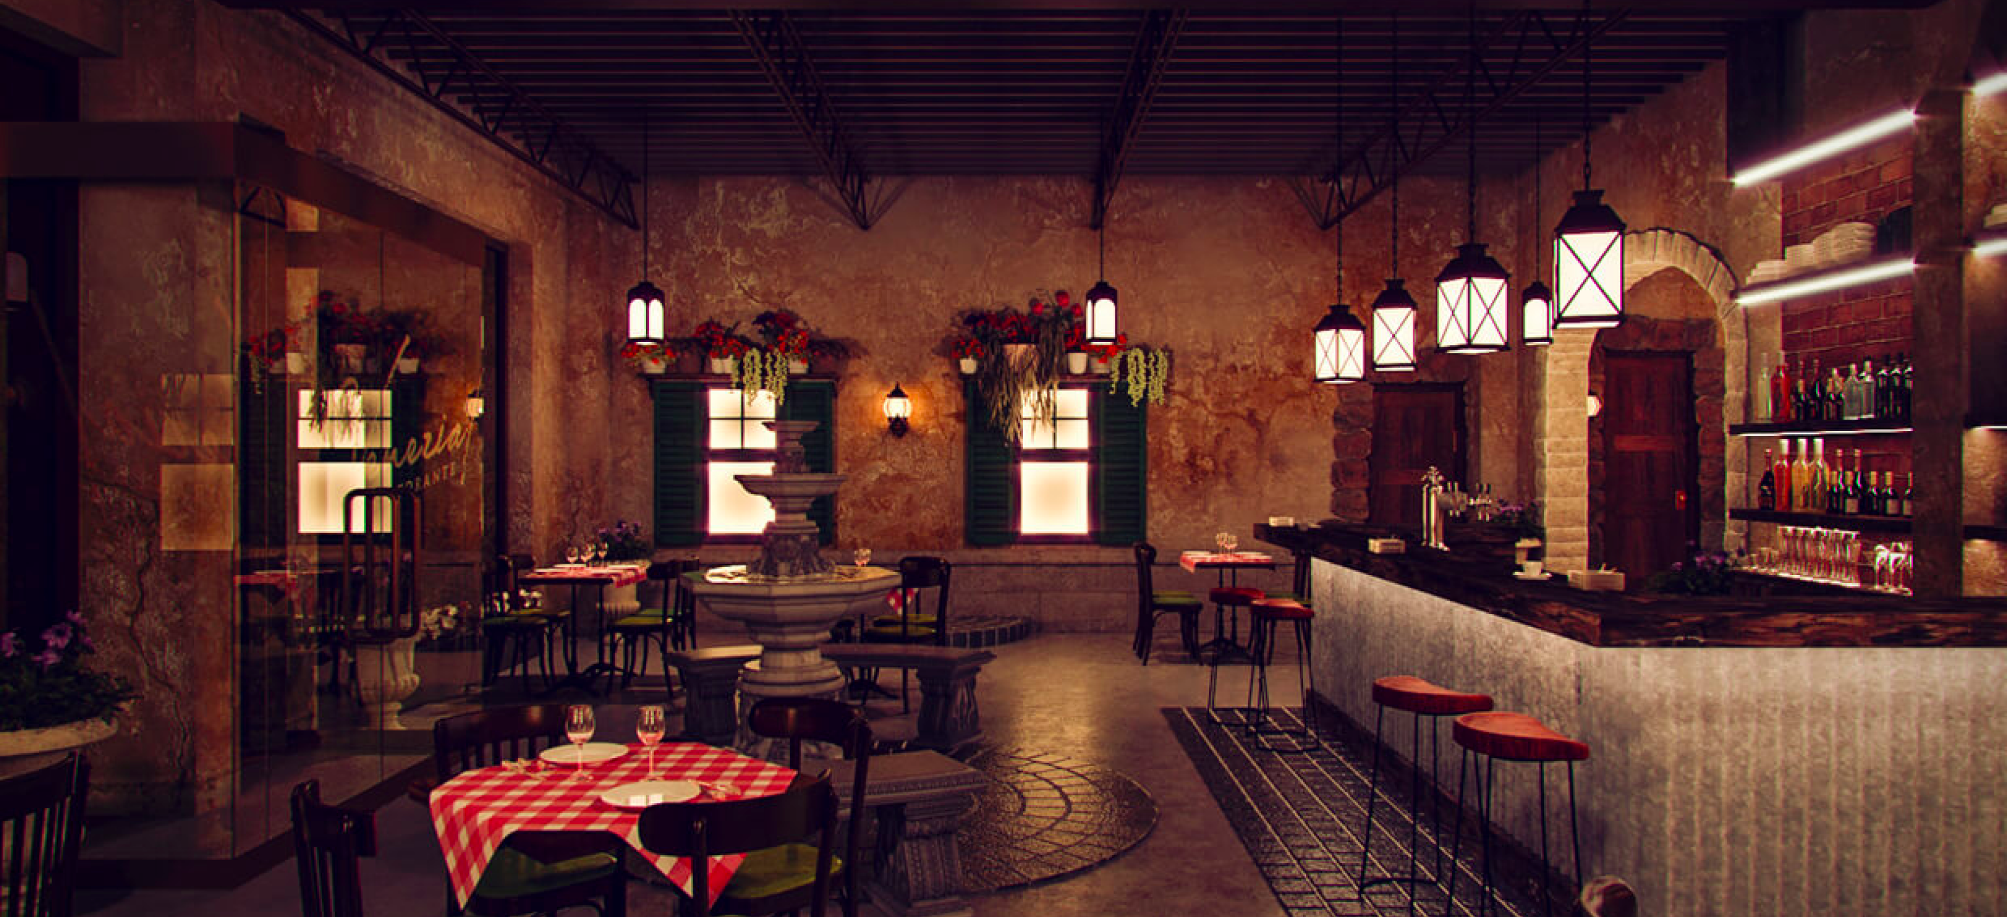

<https://comelite-arch.com/portfolio/venezia-italian-restaurant-interior-design/>

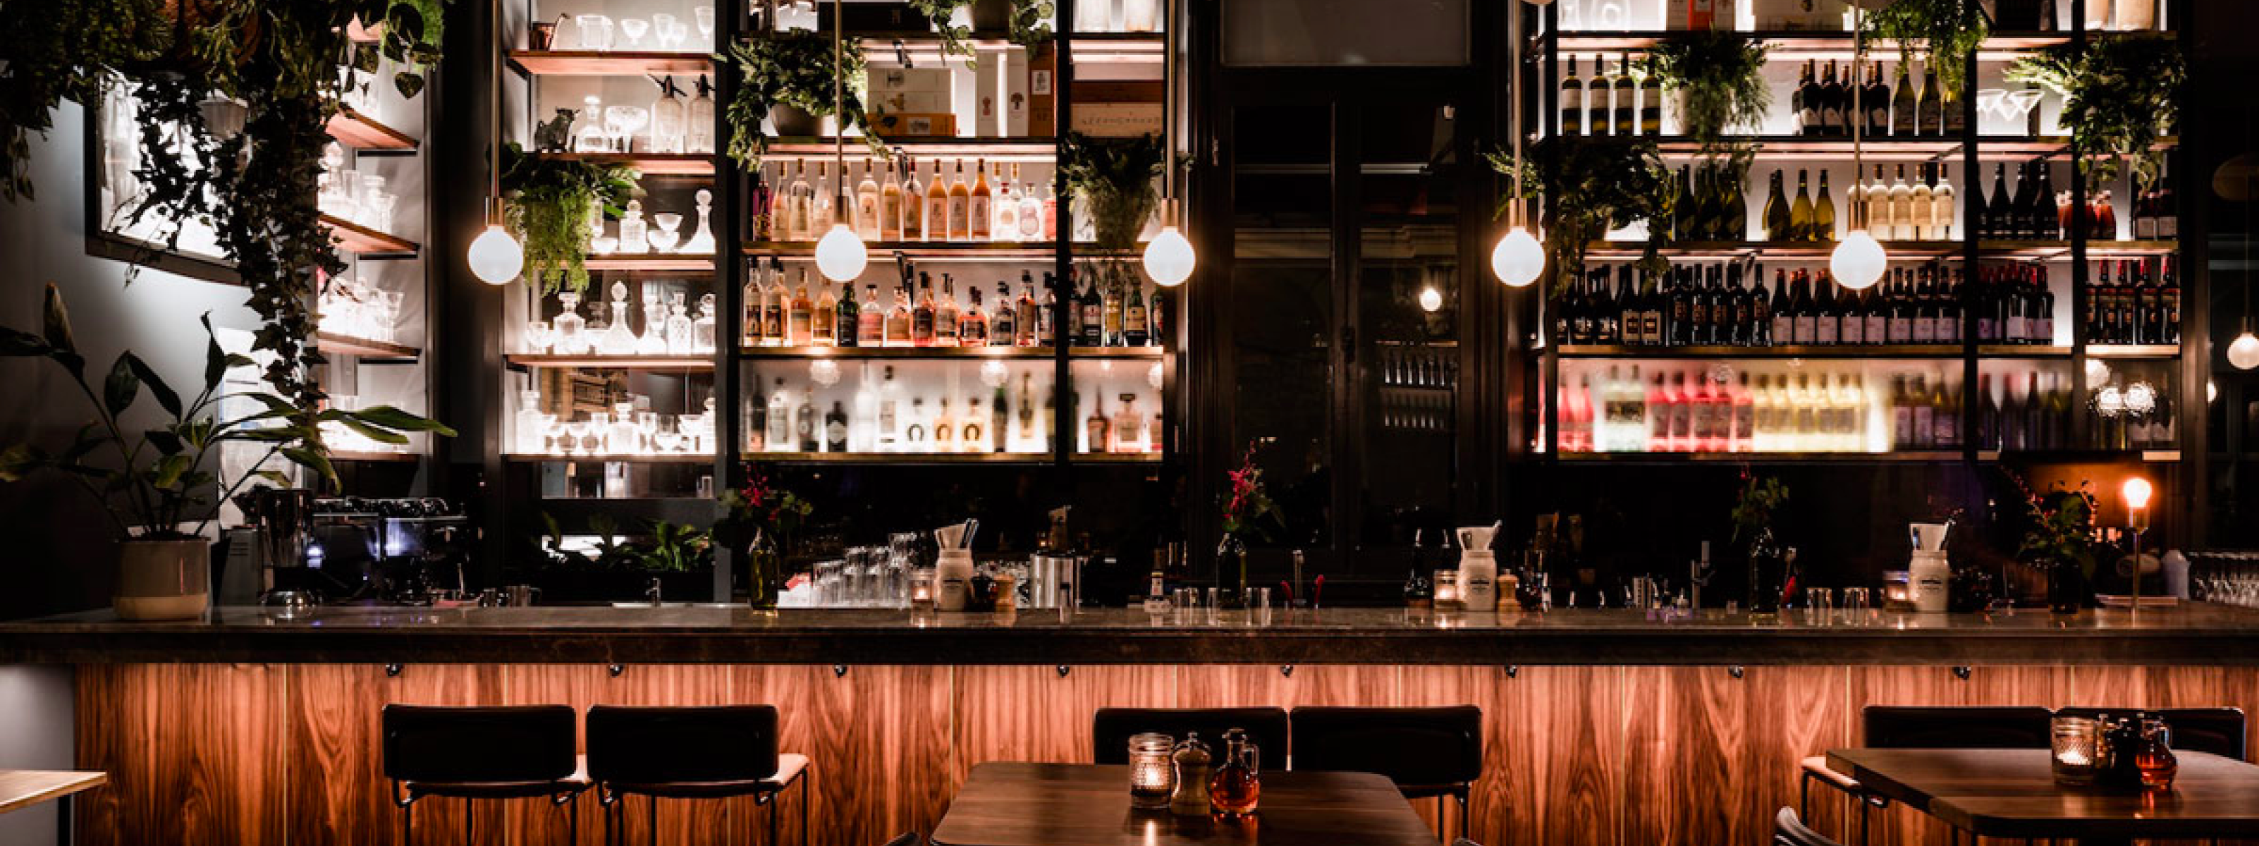

<https://concreteplayground.com/melbourne/bars/ines-wine-bar>

[Libby Curran](https://concreteplayground.com/melbourne/author/libby-curran/)MAY 16, 2018

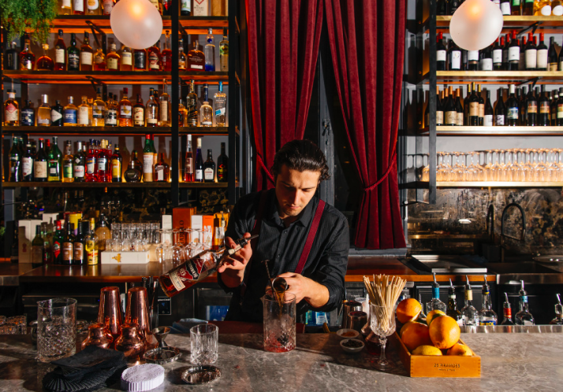

<https://no.pinterest.com/pin/857161741568993212/>

erstattning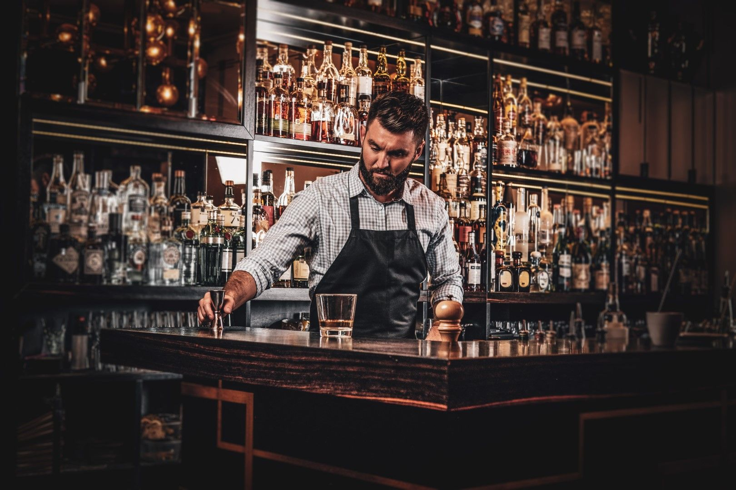



<https://toppng.com/show_download/175888/white-directions-icon-location-flat-icon-white/large>

<https://toppng.com/show_download/182525/mail-white-icon/large>

<https://freepikpsd.com/fb-white-png-transparent-images/787586/>

<https://toppng.com/show_download/17636/settings-icon-android-kitkat/large>

**Meny**

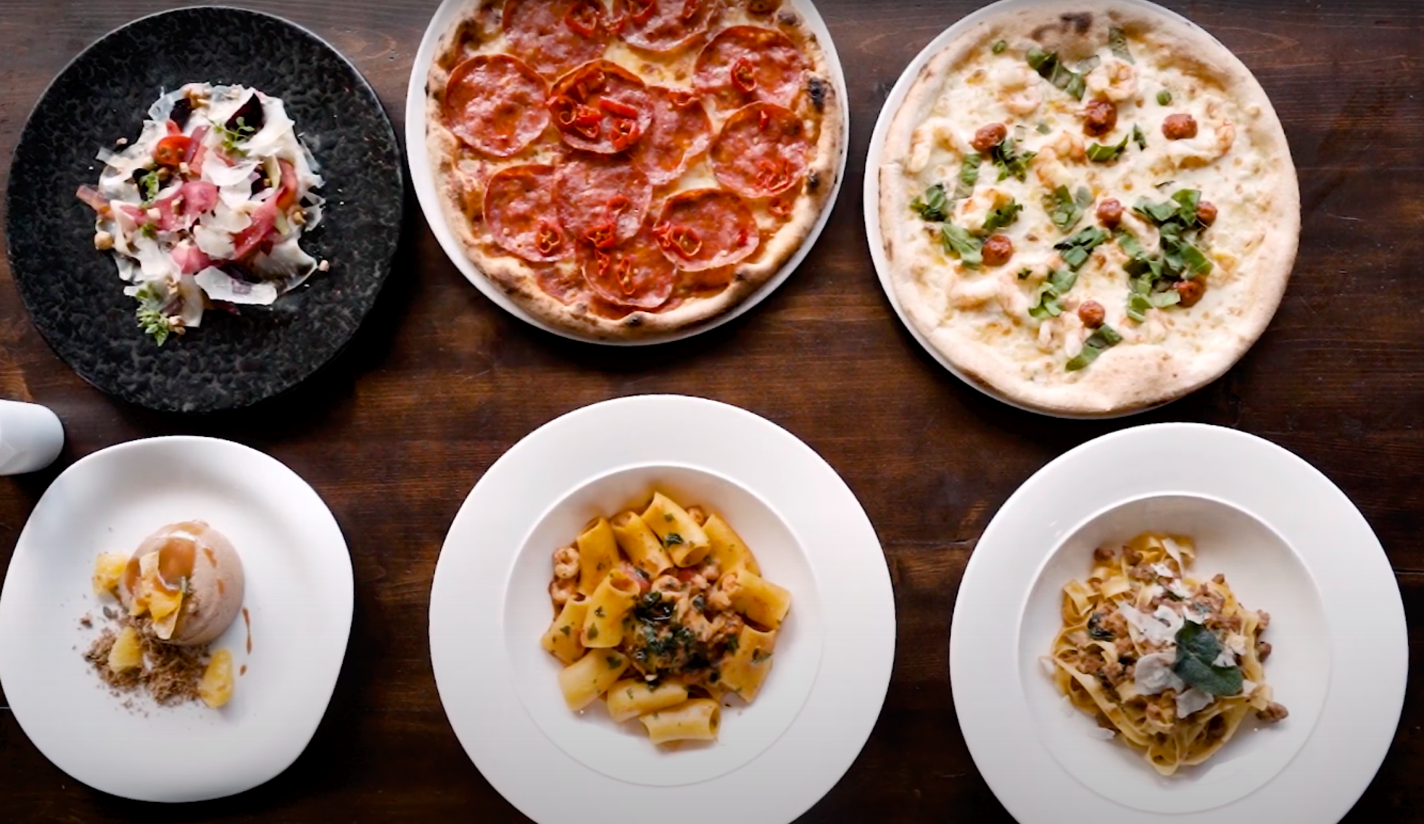

[**https://www.youtube.com/watch?v=kDtpVBzKhhE**](https://www.youtube.com/watch?v=kDtpVBzKhhE)

**0.55**



[**https://engawapraha.cz**](https://engawapraha.cz)

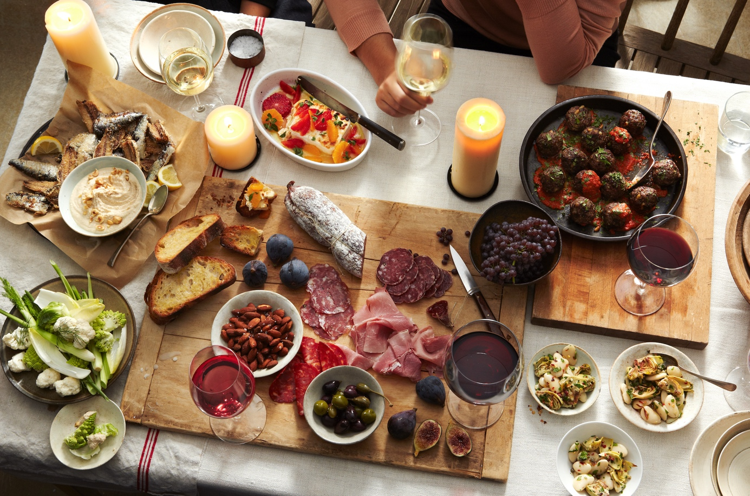

[**https://www.elle.com/culture/travel-food/g27227/how-to-host-an-italian-dinner-party/**](https://www.elle.com/culture/travel-food/g27227/how-to-host-an-italian-dinner-party/)

**Book bord**

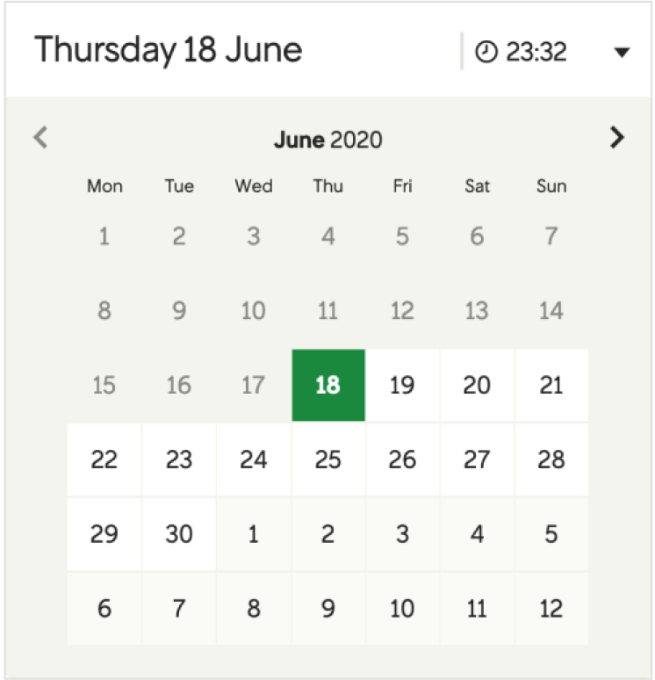

[**https://www.vy.no/?gclid=CjwKCAjw_sn8BRBrEiwAnUGJDq_p9L7ouzvgfT2V6IxShb2u8f85fk7a5ZDZsCwKGrq3eDMQpPvGDBoCsNYQAvD_BwE**](https://www.vy.no/?gclid=CjwKCAjw_sn8BRBrEiwAnUGJDq_p9L7ouzvgfT2V6IxShb2u8f85fk7a5ZDZsCwKGrq3eDMQpPvGDBoCsNYQAvD_BwE)

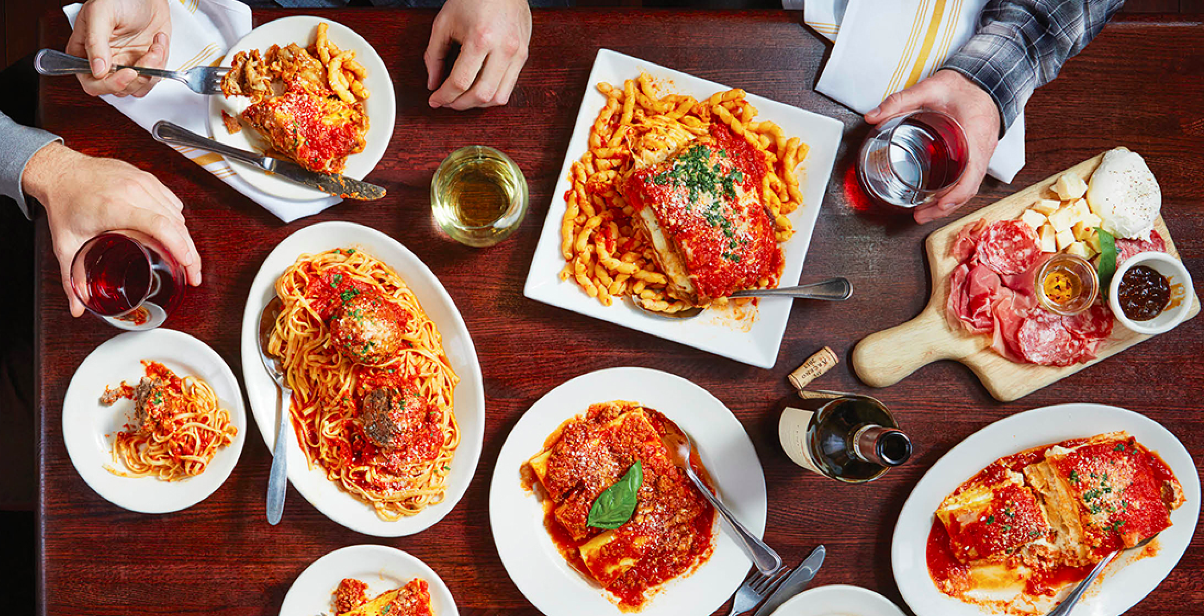

<https://www.bostonmagazine.com/restaurants/best-north-end-restaurants/>

<https://www.lafamigliagiorgios.com>

**Kontakt oss**

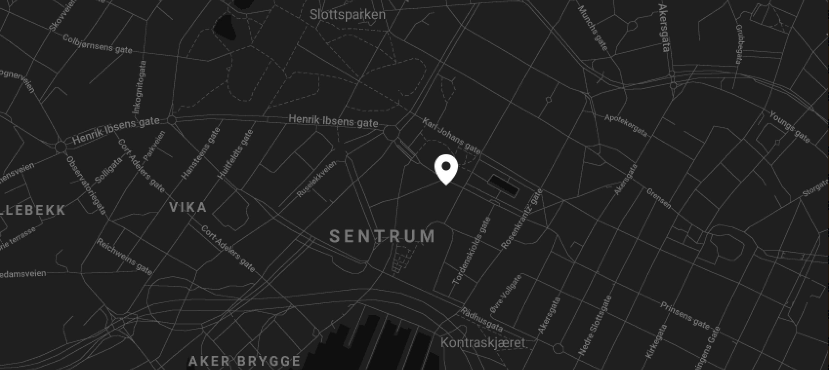

[**https://www.trondheim.no/kommandanten**](https://www.trondheim.no/kommandanten)

[**https://emilieseld.no**](https://emilieseld.no)

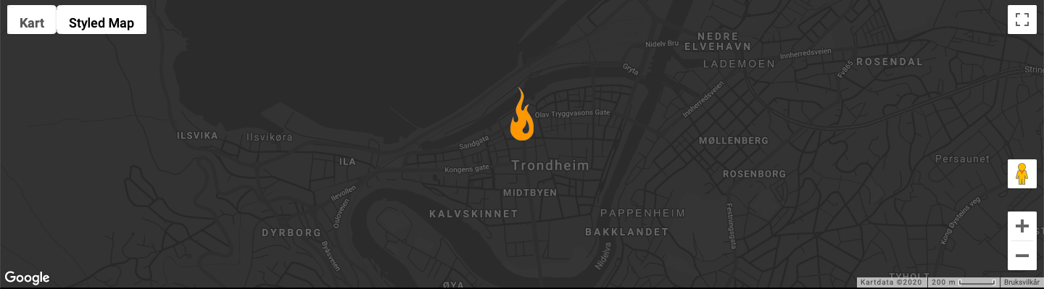

**Smitteoppsporing**

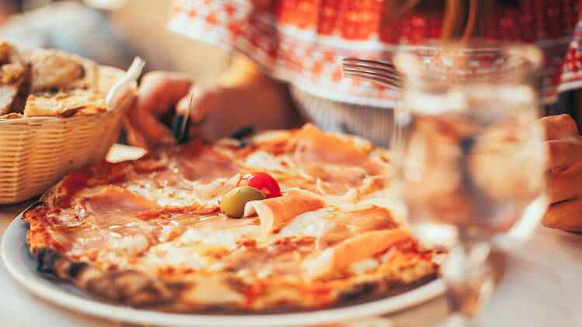

[**https://www.timeout.com/rome/restaurants/best-pizza-in-rome**](https://www.timeout.com/rome/restaurants/best-pizza-in-rome)

Angela Corrias

**Personvernerklæring**



[**https://www.restaurantchoice.com.au/join/#**](https://www.restaurantchoice.com.au/join/#)

[**https://www.restaurantchoice.com.au/contact/**](https://www.restaurantchoice.com.au/contact/)



[**https://pngimg.com/download/19692**](https://pngimg.com/download/19692)



[**https://pizzatriangle.co.uk**](https://pizzatriangle.co.uk)



[**https://www.cleanpng.com/png-foodora-pico-de-gallo-delivery-restaurant-2078500/**](https://www.cleanpng.com/png-foodora-pico-de-gallo-delivery-restaurant-2078500/)